<https://tryhackme.com/room/redteamengagements>

**Task 1 – Red Team Engagements Introduction**

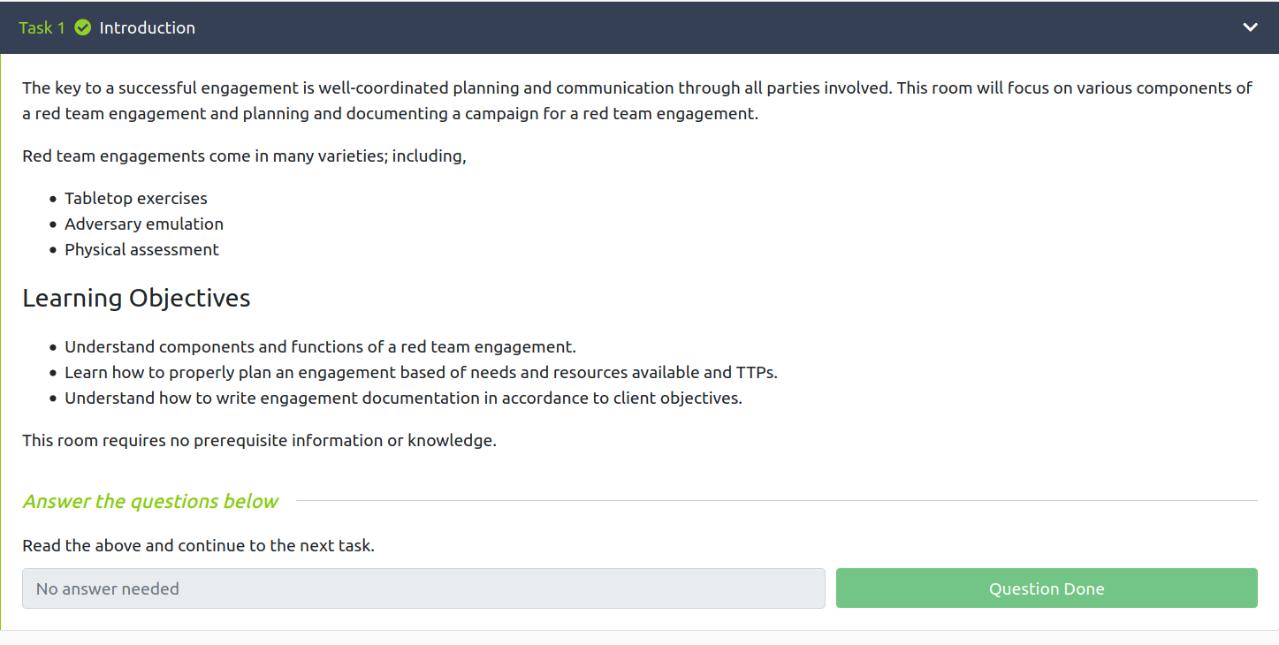

**Task 2 Defining Scope and Objectives**

1. **What CIDR range is permitted to be attacked?**

Answer: 10.0.4.0/22

1. **Is the use of white cards permitted? (Y/N)**

Answer: Y

1. **Are you permitted to access "*.bethechange.xyz?" (Y/N)**

Answer: N

**Task 3 Rules of Engagement**

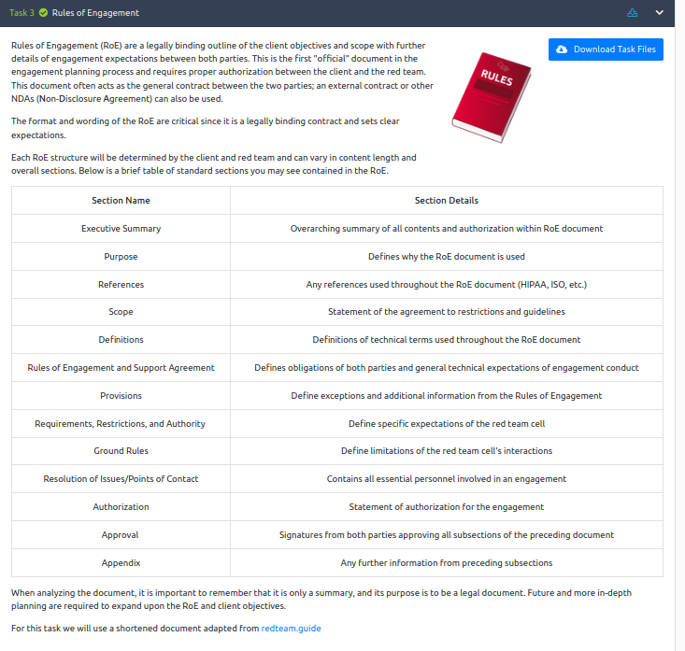

1. **How many explicit restriction are specified?**

Answer: 3

1. **What is the first access type mentioned in the document?**

Answer: Phishing

1. **Is the red team permitted to attack 192.168.1.0/24? (Y/N)**

Answer: N

**Task 4 Campaign Planning**

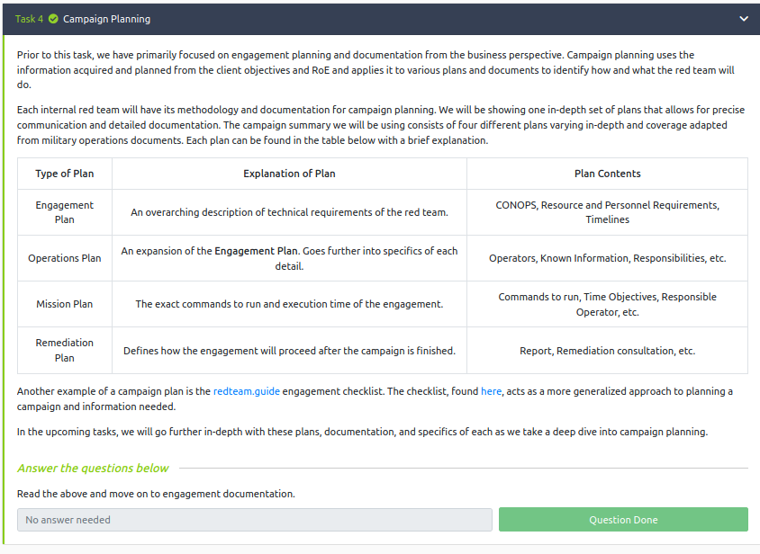

**Task 5 Engagement Documentation**

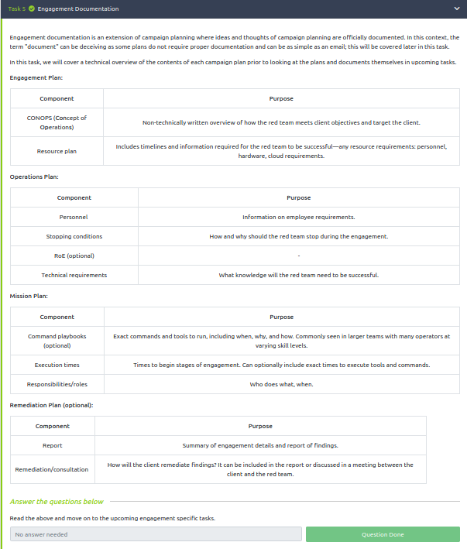

**Task 6 Concept of Operations**

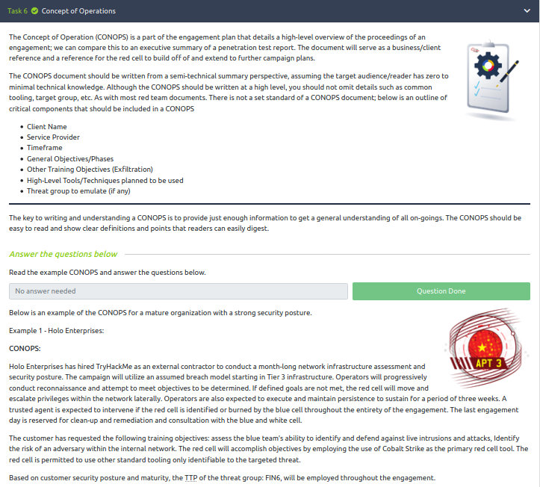

1. **How long will the engagement last?**

Answer: 1 Month

1. **How long is the red cell expected to maintain persistence?**

Answer: 3 Weeks

1. **What is the primary tool used within the engagement?**

Cobalt Strike

**Task 7 Resource Plan**

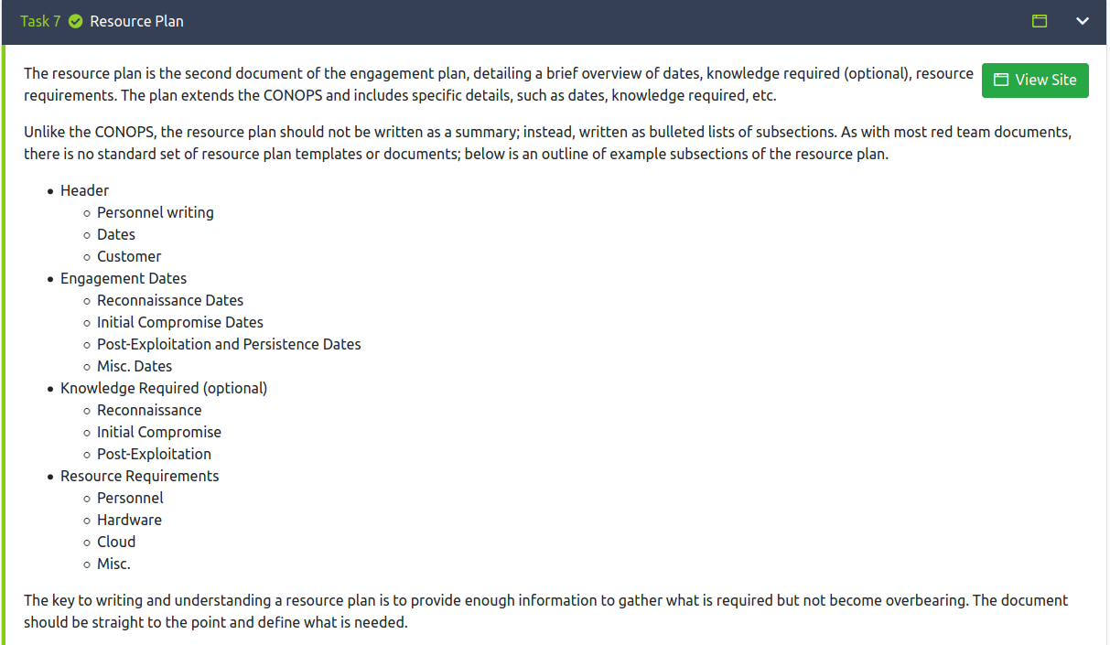

1. **When will the engagement end? (MM/DD/YYYY)**

Answer: 11/14/2021

1. **What is the budget the red team has for AWS cloud cost?**

Answer: $1000

1. **Are there any miscellaneous requirements for the engagement? (Y/N)**

Answer: N

**Task 8 Operations Plan**

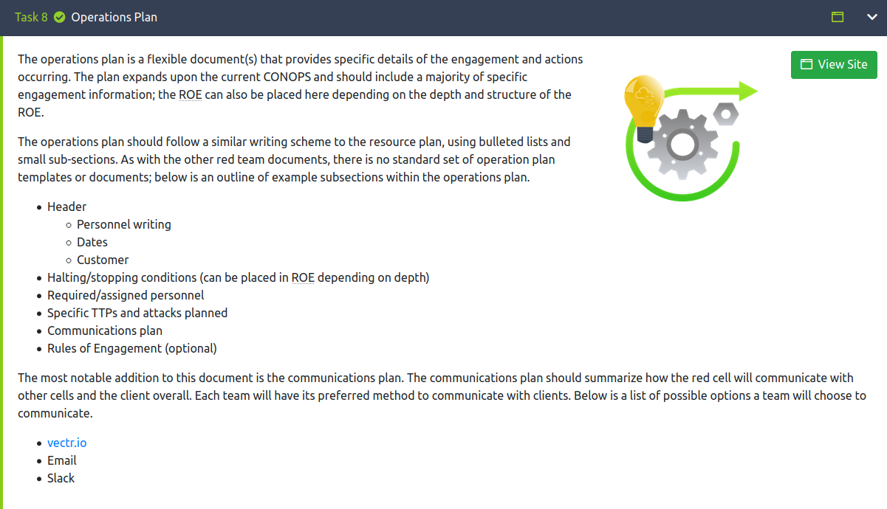

1. **What phishing method will be employed during the initial access phase?**

Answer: Spearphishing

1. **What site will be utilized for communication between the client and red cell?**

Answer: vectr.io

1. **If there is a system outage, the red cell will continue with the engagement. (T/F)**

Answer: F

**Task 9 Mission Plan**

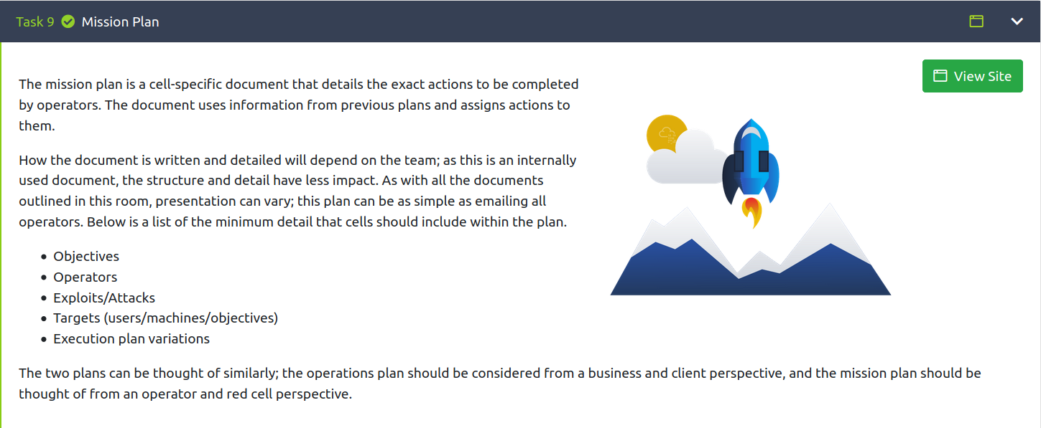

1. **When will the phishing campaign end? (mm/dd/yyyy)**

Answer: 10/23/2021

1. **Are you permitted to attack 10.10.6.78? (Y/N)**

Answer: N

1. **When a stopping condition is encountered, you should continue working and determine the solution yourself without a team lead. (T/F)**

Answer: F

**Task 10 Conclusion**

